# CS 255 System Design Document Template

This template lays out all the different sections that you need to complete for Project Two. Each section has guidance to prompt your thinking. You will need to continually reference the interview transcript as you work to make sure that you are addressing your client’s needs. There is no required length for the final document. Instead the goal is to complete each section based on what your client’s needs are. Remove this note when you are finished, and replace all bracketed text with the relevant information.

## UML Diagrams

### UML Use Case Diagram

*[In Module Six, you were asked to complete a use case diagram based on your system design. If you would like to make any adjustments to your diagram, please do so. Please insert your use case diagram here. Check to make sure that you included appropriate components and symbols and that your design meets the client’s needs.]*

### UML Activity Diagrams

*[You were asked to choose* ***two*** *use cases and create* ***two*** *activity diagrams, one for each use case. Please insert* ***both*** *of your activity diagrams here. Check to make sure that you included appropriate components and symbols and that your design meets the client’s needs.]*

Take exam activity diagram

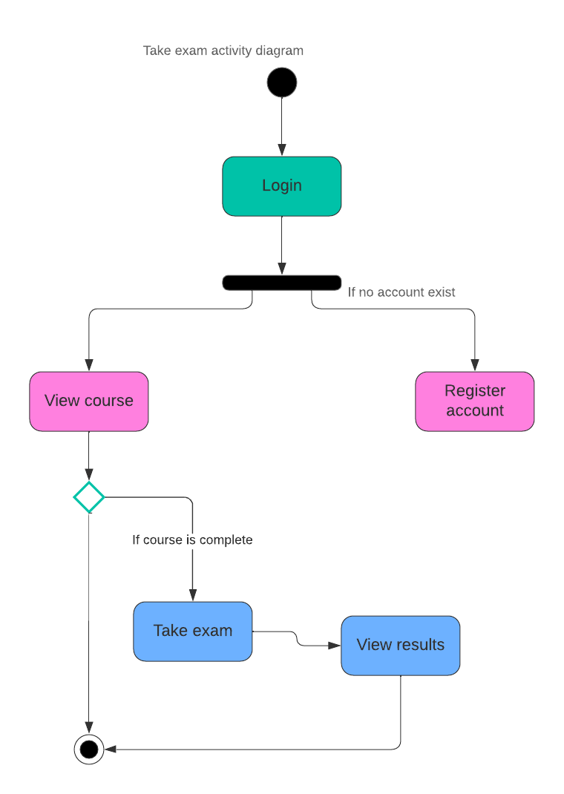

### UML Sequence Diagram

*[You were asked to create a sequence diagram based on* ***one*** *of the use cases you chose. Please insert your sequence diagram here. Check to make sure that you included appropriate components and symbols and that your design meets the client’s needs.]*

*Sequence diagram for take exam*

### UML Class Diagram

*[You were asked to create a class diagram based on the different classes and attributes needed for your system design. You are* ***not*** *required to include methods, but you may if you wish. Please insert your class diagram here. Check to make sure that you included appropriate components and symbols and that your design meets the client’s requirements.]*

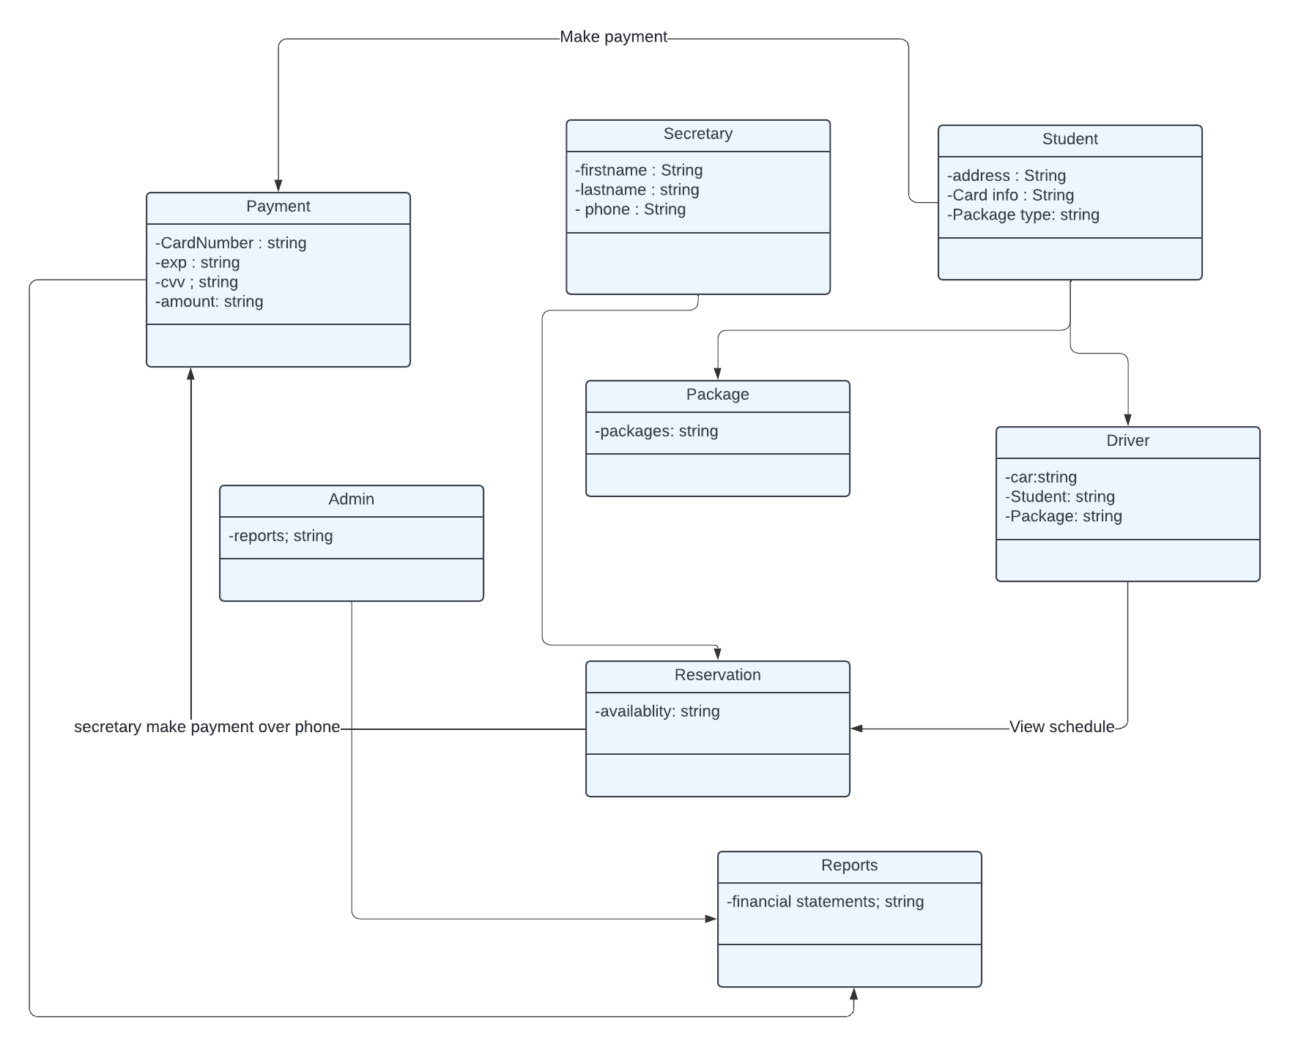

## Technical Requirements

*[Based on the diagrams you have created, describe the technical requirements of your system. These requirements should address the required hardware, software, tools, and infrastructure necessary for your system design.]*

Hardware Requirements:

1. Web servers: To host the web-based system, including the application and database servers.
2. Storage: Sufficient storage capacity to store user data, reservation information, course materials, etc.
3. Network Infrastructure: Reliable network infrastructure to ensure seamless communication between clients and servers.

Software Requirements:

1. Operating System: The system should be compatible with Windows, Unix, and other common operating systems.
2. Web Server Software: Software such as Apache or Nginx to serve the web application.
3. Database Management System: A robust DBMS like MySQL or PostgreSQL to manage the system's database.
4. Development Tools: IDEs like Visual Studio or Eclipse for development, and version control systems like Git for managing code.
5. Security Software: Software for encryption, secure data exchange, and protection against cyber threats.

Tools and Frameworks:

1. Programming Languages: The system can be developed using languages such as Java, C++, or Python for backend development, and HTML, CSS, and JavaScript for frontend development.
2. Data Serialization: Tools like JSON for data serialization.
3. API Development: Tools for developing APIs to integrate with external systems or services.

Infrastructure:

1. Cloud Infrastructure: Use of cloud services like AWS for scalability, reliability, and cost-effectiveness.
2. Backup and Recovery: Implementing backup and recovery solutions to ensure data safety and continuity of operations.
3. Scalability: Designing the system to be scalable to accommodate a growing user base and additional features.